Teaching Basic Writing
Using the Language Experience Approach (LEA)
Anne Marie Burk, English Language Specialist

What is LEA?
The Language Experience Approach is a process approach to writing. The process involves thinking, speaking, listening, writing, reading, and revising. After we review the Phases and Features of LEA, we will follow the LEA method and write a paragraph as a class. In this approach, the teacher acts only as facilitator, while students generate all written material, including organization, revisions, and corrections. In the process we experience students’ creativity, and the outcome—our paragraph—is always unique, surprising, and wonderful.

Phases of LEA
First, the prewriting phase: writers find and develop ideas about a topic. They will think about the topic and their unique experience with it. They will talk about the topic, developing vocabulary to describe their experience. Vocabulary may include transitional words and phrases so writers can relate their experience in time.
Second, the drafting phase: writers transform oral language into written language. Ideas and experience that is related orally is written down as it is spoken. The focus in the drafting phase is on content rather than correctness.
Third, the revising phase: writers will organize the written sentences to put ideas or experience in a desired sequence; they will structure the paragraph by creating both a topic sentence and a concluding sentence; and they will proof-read for expression, spelling, and grammar correctness.

Features of LEA
- Uses all communication skills—speaking, listening, reading, writing.
- Material is learner-generated.
- Difficulty of vocabulary and grammar is determined by the learners’ own language use.
- Students work collaboratively with each other and with the teacher.
- Learning and teaching are personalized, communicative, creative, and interesting.
- No books or other materials required.

Possible Topics:
- Qualities of a good day, or a good friend
- A process, like making a favorite food
- An activity they experienced, like a class field trip
- Advice, like how to learn a foreign language
- A personal problem they can explore, like how to make up after an argument
- A social problem, like how to stop bullying in school
- A plan they create, like how to achieve a dream or goal

Steps in the LEA Writing Lesson:

- Begin with a topic that students have personal experience with. Teacher says:
Our topic for today: Young people often daydream about what they would like their lives to be when they become adults. Hard work and planning can make a dream come true. Think about your goals for the future. What do you want in your life? What steps will you take to reach those goals?
Teacher gives students a minute or two to think about the topic.

- Develop vocabulary about topic. Students brainstorm words that describe the topic.
Teacher asks about topic: What do you want in life and how will you reach your goals?
Teacher writes our ideas on the board, in a list or cluster diagram.
Develop vocabulary that indicates time. Teacher asks for transition words that will organize our ideas. Students call out words like first, next, after that, finally.
Teacher writes these on the board.

- Pre-writing activity: Students talk in pairs, sharing their experience and ideas (about 2 minutes each). Teachers may have students talk in several pairs to get more ideas, to develop their thoughts, and to practice speaking English.

- Create sentences about topic.
Teacher asks, “What can we say in sentences about this topic?”
Students dictate sentences which teacher writes on the board exactly as students dictate. Teacher and students read sentences out loud as a class. Students may make additions, corrections, and revisions. Teacher writes these down.

- Write a paragraph from the sentences. Use another part of the board.
- Teacher asks, “Do we have a topic sentence?” Students either select or create one. Teacher writes this down.
- Teacher asks, “What next?” Students select which sentences should follow. Teacher writes them on the board, again exactly as dictated.
- After enough supporting sentences have been written down, Teacher asks, “What would be a good concluding sentence?” Students either select or create one.

- Correct/Edit/Revise. Teacher asks class to find areas in the paragraph they might like to correct or change. Students suggest revisions. Teacher may indicate problem areas by underlining. Teacher may ask, “Do all our sentences relate to the topic?”
Some possible revisions:
- Subject-verb agreement, verb tenses
- Vocabulary, word choice, adjectives, adverbs, spelling
- Do we need more information to be clear to our readers?

- As a class, create a descriptive title.

- Class reads the paragraph out loud and students copy the paragraph in their notebooks. They can use the paragraph as a model to write their own original text.
The Teacher’s Role in LEA
- Teacher asks for vocabulary and ideas.
- Teacher should be supportive of what the learners have to say.
- Teacher may help expand or focus the account by asking questions.
- Teacher writes exactly as the learners dictate. Keep the focus on the content rather than the form. Length is not important. Beginners may have only a few sentences.
- Teacher does not correct language at this point, although learners may correct themselves and each other.
- Oral reading promotes rethinking and revision, so can be done at many points during the writing process.

Teacher’s Goal: to give your students self-confidence. Show them how they can be successful in transforming spoken language into written language.

Extend the Experience
For Beginners:
- Students copy the story in their notebooks
- Students draw pictures of the story
- Students create a story board with 4 to 6 pictures and text
- Students read the story chorally or with a partner
- Students read silently, then cover the text and retell the story to each other.
- Teacher selects words from the story for vocabulary, spelling, grammar work.
The Next day:
- Cut sentences into words and have students put them in proper order.
- Scramble the sentences and have students rewrite them in proper order.
For More Advanced Learners:
- Students rewrite the text, but change the tense from past to future.
- Students use the text as the basis for their own original writing about the same topic
OR a similar experience. They may expand their writing to more than one paragraph.
- Students then read each other’s original writing.
- They ask classmates questions about their writing.
- Students revise and edit their writing to prepare them for publication.
- Publish student writing in booklets or post them on bulletin boards.
In Classes with Learners at Different Levels:
- Students who cannot write can draw.
- Use beginner activities with learners at lower levels while . . .
- More proficient learners work on more advanced activities, either
individually or in groups.
- Students of different levels can work together to write text and create story boards.
As students see their personal experience transcribed into writing, they gain an understanding of the “process” of writing and can make a bridge to writing independently.

LEA = A Bridge
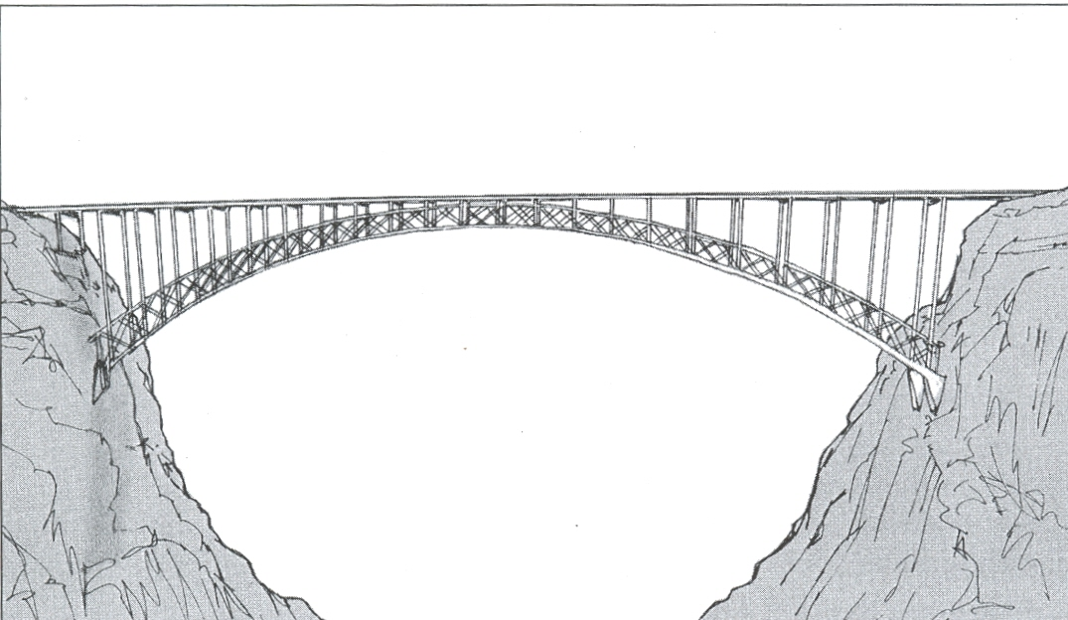

LEA creates a natural bridge between spoken language and written language.
It integrates the skills of Speaking, Listening, Writing, and Reading. Students learn:
“What I can say, I can write.”
“Writing is a process that involves thinking, talking, writing, reading what I write, and revising.”

What are the results of using the LEA writing process?

- Writing is more meaningful because it comes from students’ own thinking.
- Students see how ideas can be clustered together and organized.
- Students develop an understanding that writing is a process that involves revising.
- Teachers can give more responsibility for correction and revision to the students.
- Students develop independent thinking skills and take pride in their work.
- Students develop a better attitude toward writing: “I can do it!”

